https://www.freecodecamp.org/news/how-to-deploy-a-react-app-with-firebase/

Step1: npm install firebase

Step2: npm install -g firebase-tools

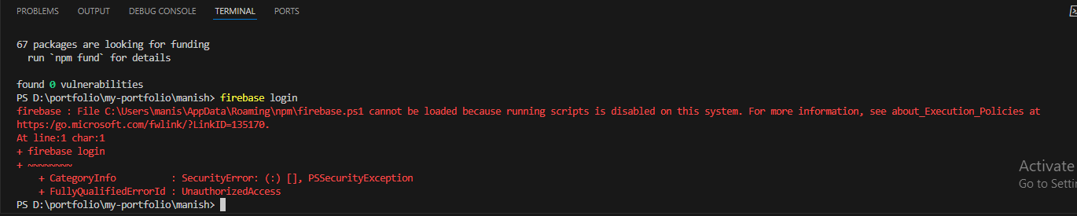

To fix the issue above, run the below code in the power shell as administrator.

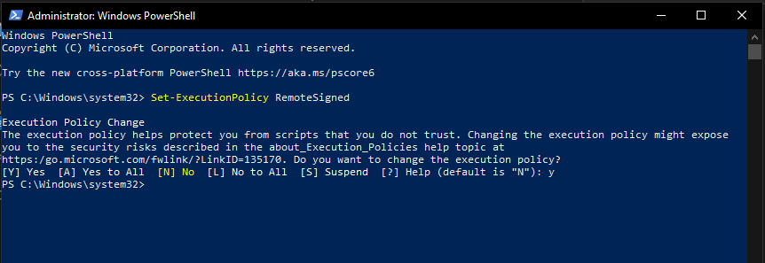

PS C:\> Set-ExecutionPolicy RemoteSigned

Step3: firebase login

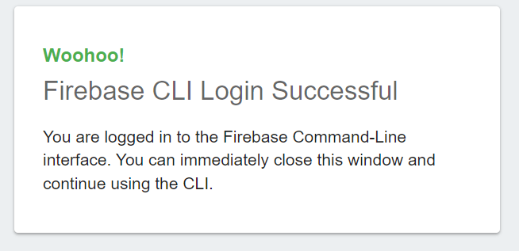

Step4: npm run build

Step5: firebase init

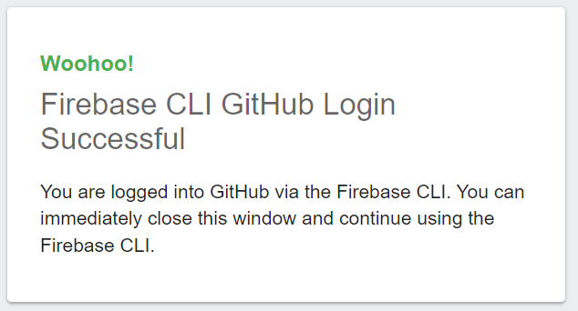

Step6: Please select an option: Do not select Use an existing project.

Step7: For which GitHub repository would you like to set up a GitHub workflow? (format: user/repository) manishkharbuja389/my_portfolio

Step8: npm ci && npm run build

Step9: firebase deploy

You can also use vercel to deploy you reat app.

https://vercel.com/guides/deploying-react-with-vercel